# User Guide for Clearing Caches on all Major Browsers

Revision History

| **Date** | **Description** | **Version** | **Author** |
| --- | --- | --- | --- |
| 01/01/2025 | Initial Draft | 1.0 | Akash |

Table of Contents

1. About Clearing Browser Caches……………………………………………………………..……….…4
   1. Intended Audience…………………………………………………………………….…...…..4
2. Ensuring Your Browser is Updated………………………………………………………………....…...5
   1. Updating Google Chrome…………………………………………………………………...…5
   2. Updating Microsoft Edge…………………………………………………………………...….7
   3. Updating Firefox………………………………………………………………………..…...…9
   4. Updating Safari………………………………………………………………….……………11
3. Clearing Browser Caches………………………………………………………………………………14
   1. Clearing Google Chrome Browser Cache……………………………………………...….….14
   2. Clearing Microsoft Edge Browser Cache………………………………………………...…..17
   3. Clearing Firefox Browser Cache……………………………………………………….……..20
   4. Clearing Safari Browser Cache………………………………………………………….……24

1.0 About Clearing Browser Caches

Every browser keeps a number of cookies or a “cache” about each website you visit. Cookies are small bits of data stored in your browser cache which remember bits and pieces about websites you visit. They help load pictures easier, remember your shopping cart, remember certain pathways between web pages, and can even remember your username or password. After a certain amount of time, this cache takes up a significant amount of space on your hard drive and can make your computer run slower. Also, when websites are updated, this cache of cookies can cause problems as it may be remembering certain pathways and things about websites that are no longer there or function differently. It is important to periodically clear your browser’s cache so that your computer can run faster and load web pages more efficiently.

* 1. Intended Audience

This user guide is for all Genesis customers who use our browser-based software. This user guide serves as a reference for how to clear browser caches for all major browsers.

2.0 Ensuring Your Browser is Updated

You will have to ensure that your browser is updated to the latest version before continuing. This is for two main reasons. First, the steps to clear your browser cache may be different between older and newer versions of your browser. Second, updating your browser to the latest version ensures web pages will load and function with as few problems as possible.

2.1 Updating Google Chrome

To update Google Chrome to the latest version, open Chrome, and then click the three dots in the upper right hand corner. This will open up a pop-out menu on the right-hand side of the browser window. Hover over “Help” at the bottom, just above “Exit”. This will create another pop-out menu with four options listed. Click “About Google Chrome” at the top of the list.

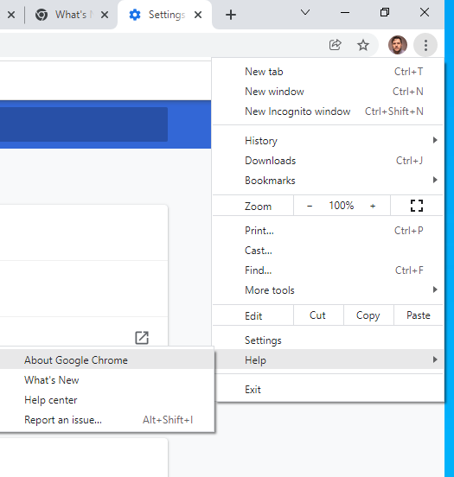

Next, you will be brought to a screen which will tell you in a text box in the center if Google Chrome is up to date or needs to be updated. If a button which reads “Relaunch” in blue is clickable to the right of this text box, then your browser needs to be updated. Simply click “Relaunch” to update Google Chrome.

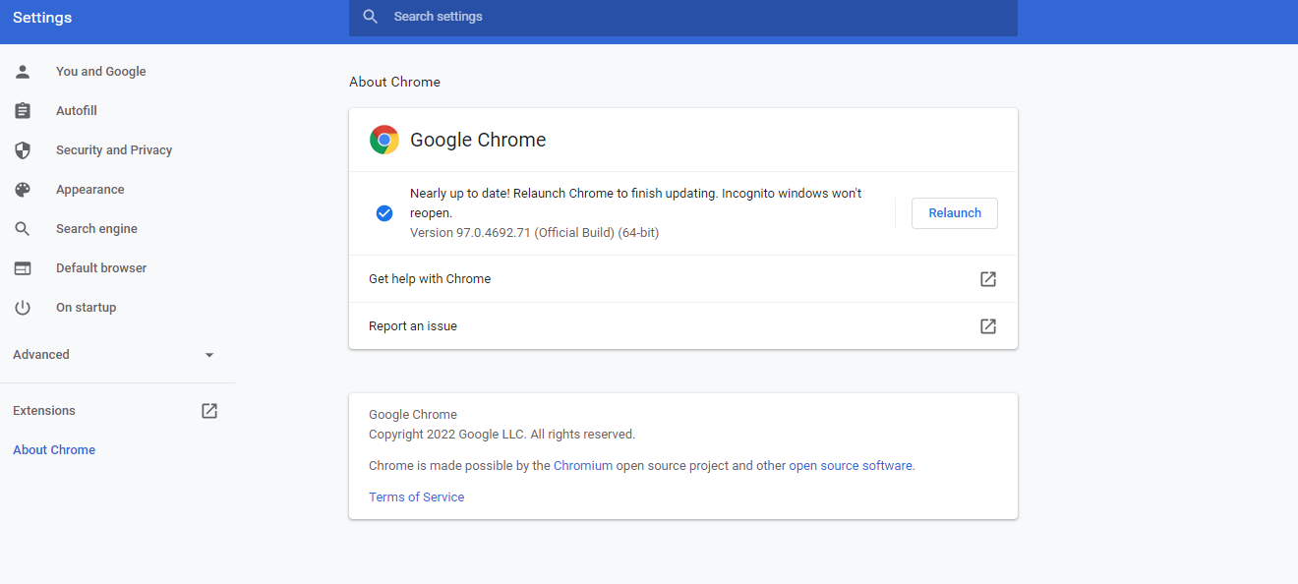

After relaunching, going through the same steps as above will bring you to the same screen, which should now read, “Chrome is up to date”.

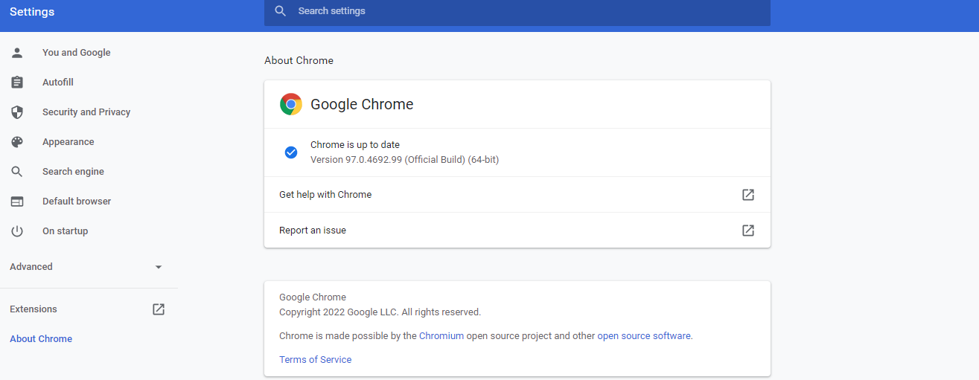

2.2 Updating Microsoft Edge

To update Microsoft Edge to the latest version, open Microsoft Edge and click the three horizontal dots in the upper right-hand corner. This will open a pop-out menu on the right side of the browser. Scroll down to “Help and Feedback” at the bottom just above “Close Microsoft Edge”. This will open another, small pop-out menu with five options. Click “About Microsoft Edge” at the bottom of this menu.

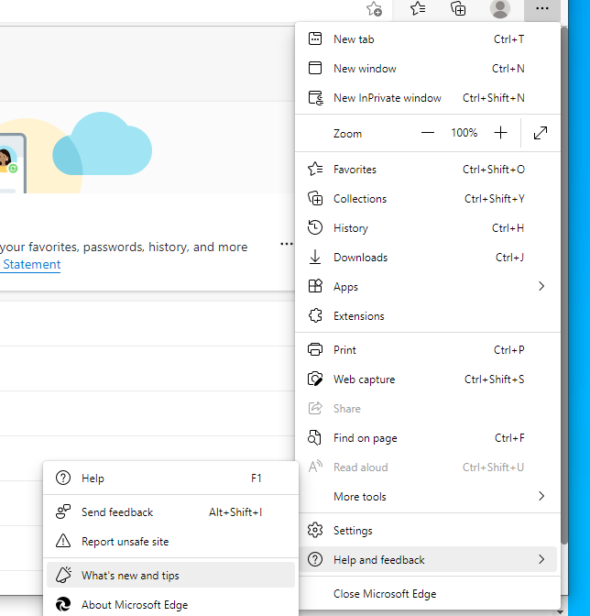

This will bring you to a screen which reads “About”. On this screen, you can see if Microsoft Edge needs to be updated by whether or not it reads “an update is needed” and has an option to download the latest version, or it will read “Microsoft Edge is up to date” if no updating is necessary.

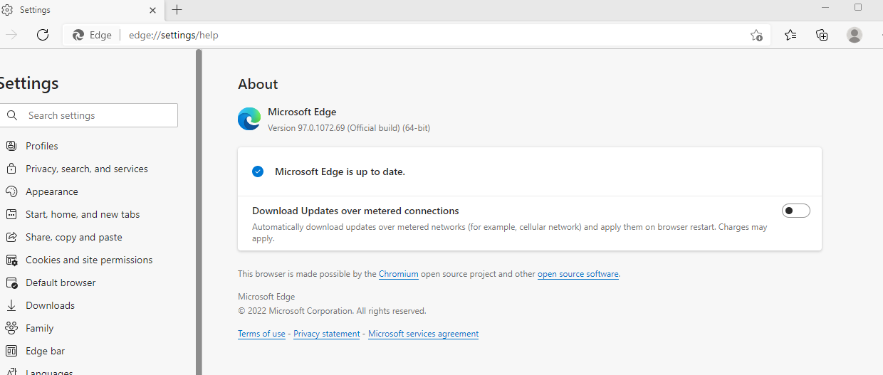

2.3 Updating Firefox

To update Firefox, open the browser, then click the three horizontal lines on the upper right-hand side of the screen. This will immediately open a pop-out menu with a list of options. At the bottom of this menu, click “Help”, just above “Exit”.

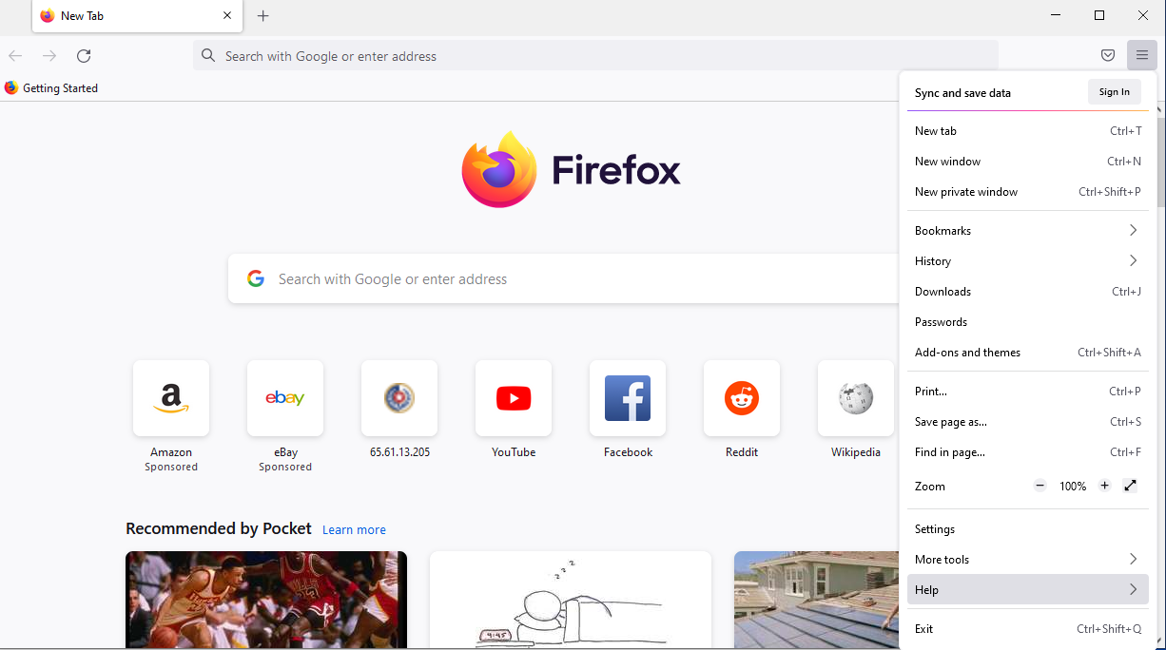

This will change the pop-out menu to a second menu which reads “Firefox Help” at the top. In this menu, click “About Firefox” at the bottom.

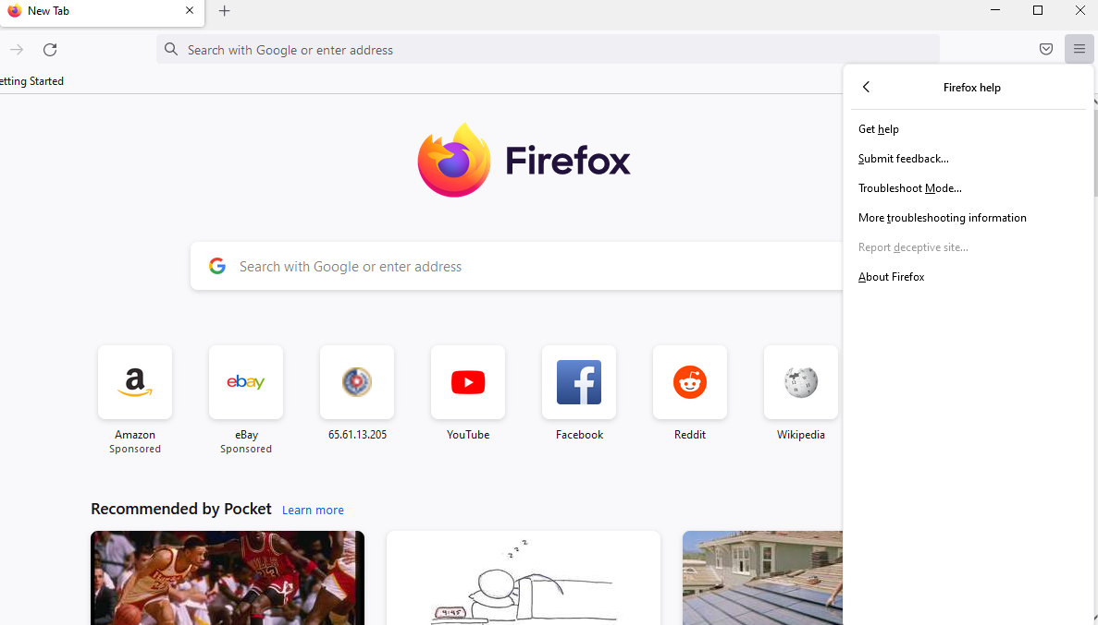

This will open a pop-up screen which will immediately update Firefox if it needs to be updated.

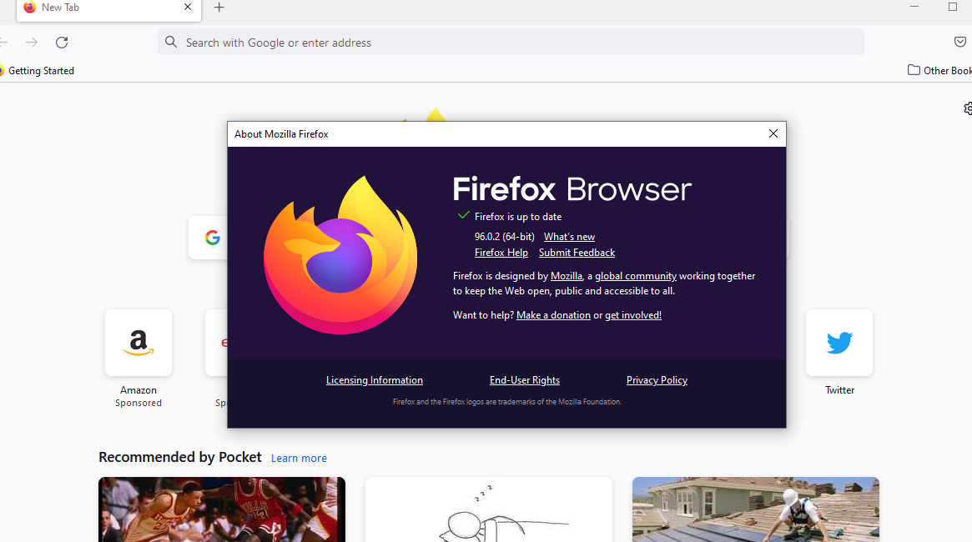

2.4 Updating Safari

To update Safari on your Mac, click on the Apple icon in the top left hand corner of your screen. A list of menu options will open, including “System Preferences” second from the top.



Clicking “System Preferences” will open up a pop-up window with a range of options and icons. Either use the search bar at the top right to search for “Software Update,” or find the Software Update icon which should appear as a gear.



This will open a window which tells you what software updates are needed on your Mac. Where it says “Other updates are available” there should be blue, clickable text underneath which reads “More info…” click this to proceed to the next step.

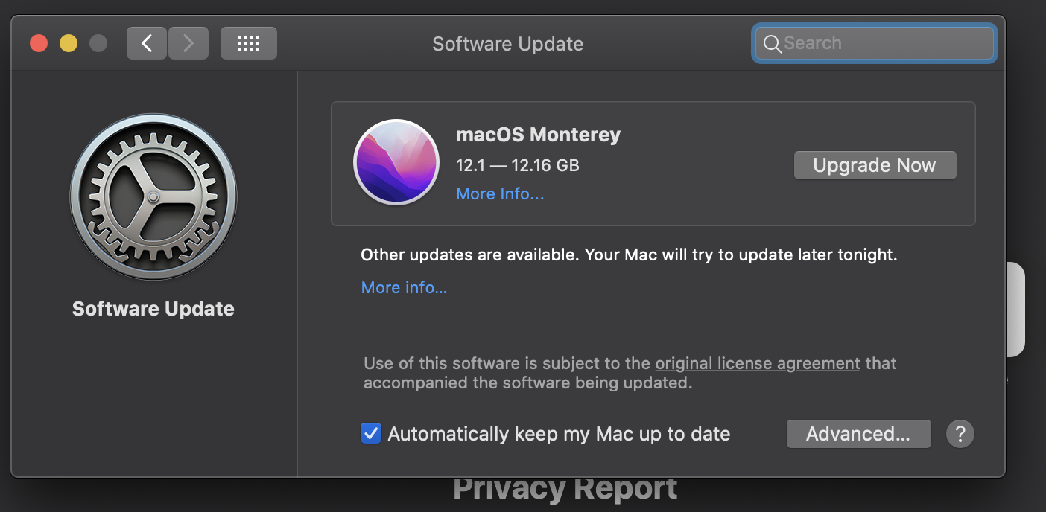

After clicking “More info…” a screen will pop up telling you whether or not Safari needs to be updated. If it does, click the blue “Install Now” button on the bottom right.



1. Clearing Browser Caches
   1. Clearing Google Chrome Browser Cache

To clear the browser cache in Google Chrome, first open the browser, and ensure the browser is up to date (see step 2.1), and click the three vertical dots in the upper right hand corner. This will open a pop-out menu with a list of options. In the second section of the menu, the fourth option down should read “History”. Hovering over this option will open another pop-out menu with your most recently access websites and an option for “History” at the top.

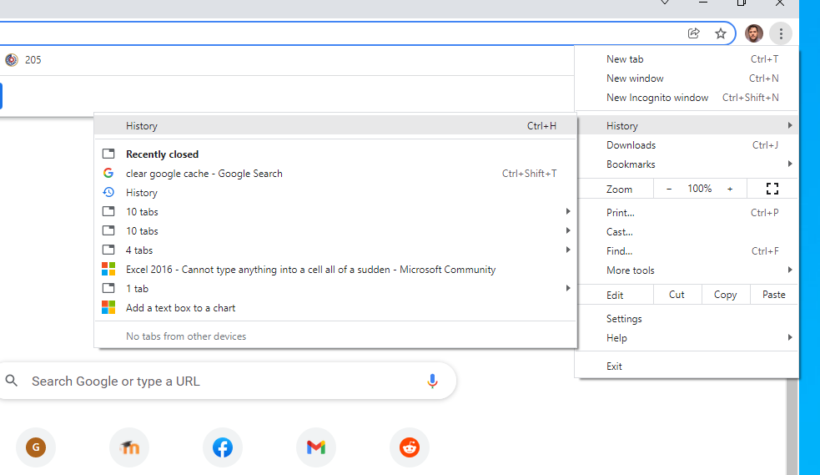

Clicking “History” will bring you to a screen which reads “History” in the blue bar at the top as well as a list of your most recently accessed websites. The second option down on the right-hand side should read “Clear Browsing Data” with an icon to the right of it.

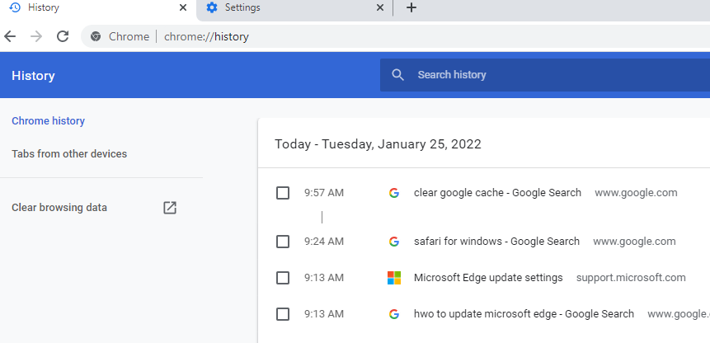

Clicking “Clear browsing data” will open a pop-up window which reads “Clear browsing data” at the top. Make sure that the options for “Browsing history,” “Cookies and other site data,” and “Cached images and files” are all selected. On the drop-down menu above these options, select “All time” from the bottom”. Then click the blue, “Clear data” button at the bottom right-hand side of the window.

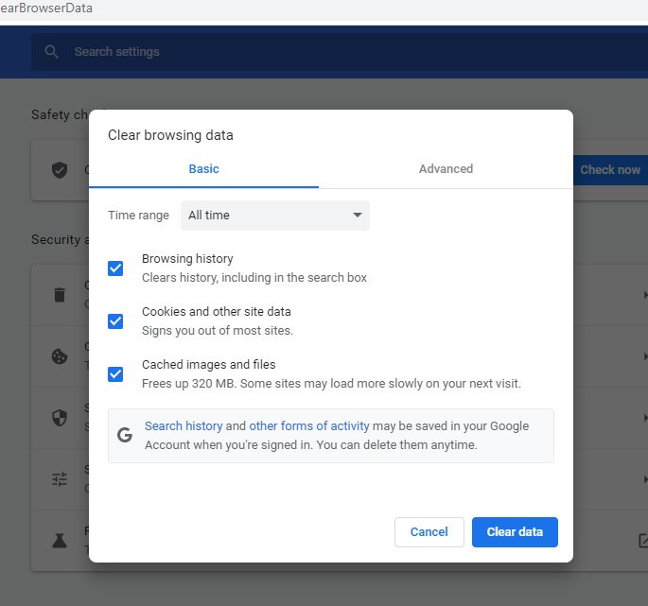

3.2 Clearing Microsoft Edge Browser Cache

To clear your cache in Microsoft Edge, first open the browser and click the three horizontal dots at the top right hand side of the window. This will open a pop-out window with a list of options. Near the top, the seventh option down should say “History”.

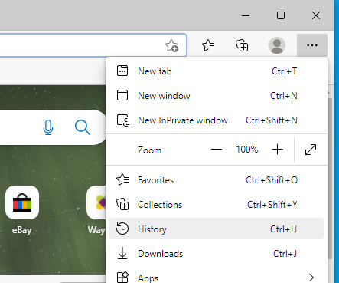

Clicking “History” will open another pop-up window Which reads “History” at the top. At the upper right-hand side of this window are three icons. Click the icon in the middle, the three horizontal dots.

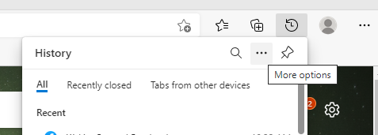

Clicking the three horizontal dots will open a small pop-up window with three options. Click “Open history page” at the top.

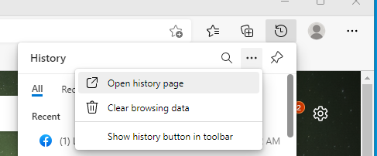

This will open a new page in your Microsoft Edge browser which should read “History” at the top left. On the opposite side of where it says “History,” you’ll see a trash can icon with the words “Clear browsing data” next to it.

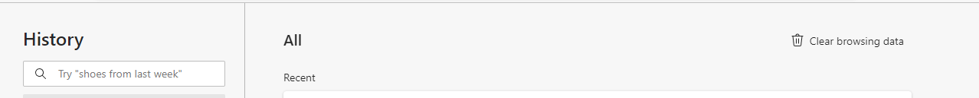

Click this icon to open a new pop-up window which reads “Clear browsing data” at the top. Ensure that each of the top four options are selected and click the blue “Clear now” button at the bottom right of this window.

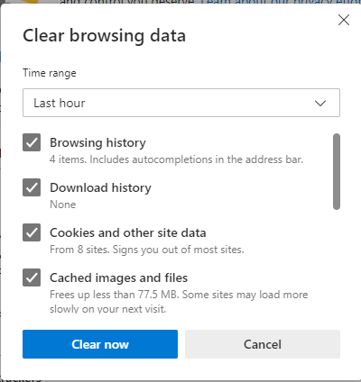

3.3 Clearing Firefox Browser Cache

To clear your cache in Firefox, first open the browser, and click on the three horizontal lines on the upper right hand side of the screen.

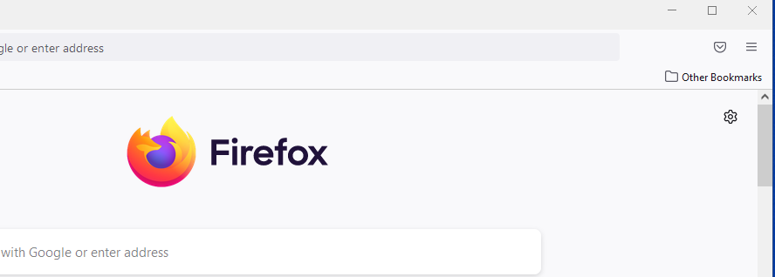

This will open a pop-out menu with a list of options. Click on the sixth option from the top, which should read “History”.

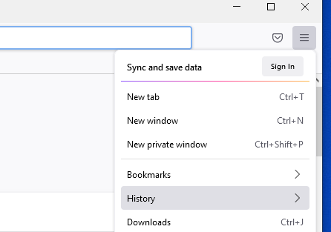

This will open a new pop-out window with another list of options to choose from. Choose the third option from the top which should read “Clear recent history”.

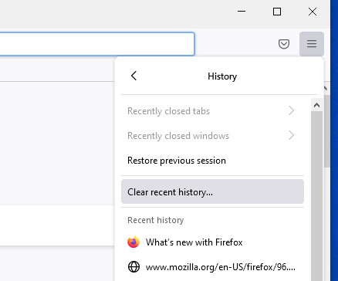

This will open a new pop-up window which reads “Clear Recent History” at the top. Ensure that all of the options under “History” are checked. Then, from the drop-down menu which reads “Time range to clear:” choose “Everything” from the bottom.

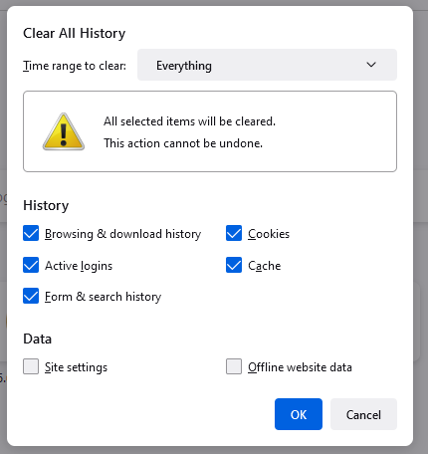

Then click the blue “OK” button on the bottom right hand side next to the “Cancel” button.

3.4 Clearing Safari Browser Cache

To clear your browser cache in Safari, first, open Safari on your Mac. When the browser is open, you should see several options across the top, left-hand side of the screen, starting with the Apple logo and “Safari”. In the middle of these options, you’ll see an option for “History”.



Clicking “History” will open up a menu which has “Show All History” at the top and “Clear History” at the bottom. Click “Clear History”.

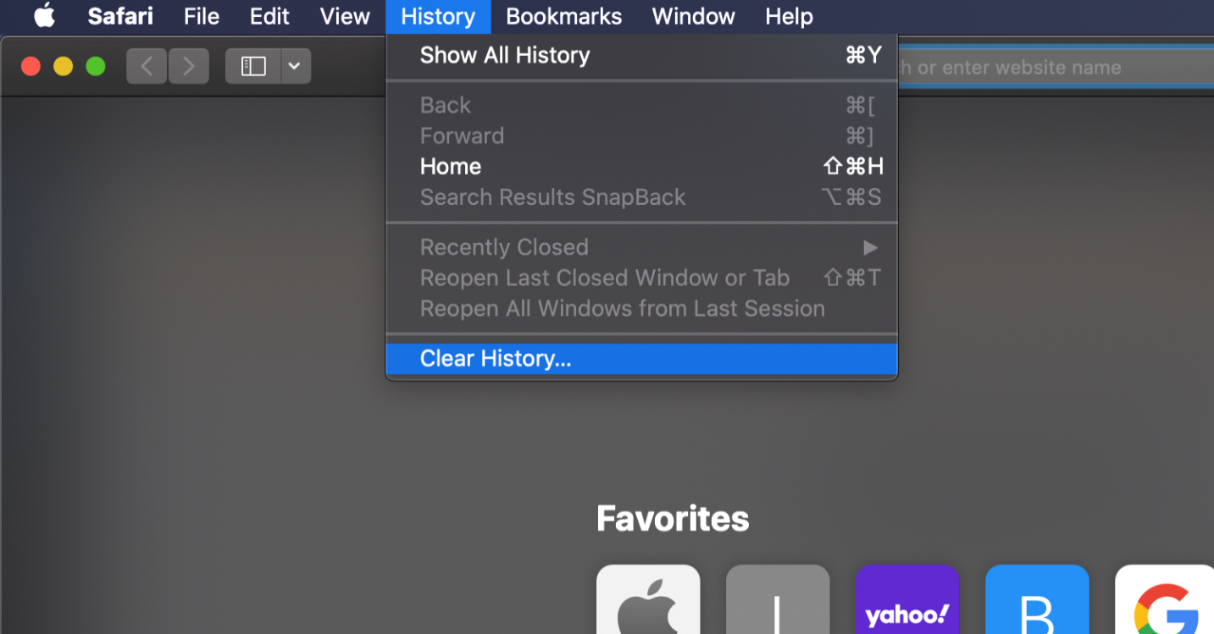

Clicking “Clear History” will open up a pop-up window which says, “Clearing history will remove related cookies and other website data. From the drop-down menu in the middle of this window, select “all history” and then click the “Clear history” button on the bottom right of the window.

